Deployment Guide for B2B
Hybris Deployment Overview
- Overview
Installation

- System Requirements
- Build Hybris Commerce
- Installing and Initializing SAP Hybris Commerce Using the Installer for custom store setup

Deployment of eEyewear
- Development of customizing eEyewear Store:
- Working On a Team Forge project
  - How to check-out source code into TeamForge repository
  - How to check-in source code into TeamForge repository
- Working With SVN in Eclipse
  - Steps for installation SVN plug-in
  - Steps for Checkout code through Eclipse
  - Committing Changes to the Repository
Documentation
- Documentation Guide

INTRODUCTION
The Hybris Commerce Suite is a very lightweight and completely Java-based application that runs on many system combinations. For a quick start, it is important to know the basic software and hardware requirements for running the Hybris Commerce Suite.
SYSTEM REQUIRMENTS:
For Demonstration and Development
These requirements apply to the use of the Hybris software itself, not to 3rd party applications or databases. These requirements assume a typical scenario based on Hybris Platform, Commerce product package, PIM product package, MySQL as database, Eclipse, and embedded Tomcat web server.
The Minimum scenario should be sufficient for demonstrating the software in sales and presale presentations. Our tests have shown that for smooth development you need to fulfil the system requirements as listed under Recommended.

Demonstration/Development | Minimum | Recommended
CPU | Dual Core, for example i5 | Quad Core, for example i7
RAM ^{[2]} | 8 GB | 16 GB
Hard Disk ^{[3]} | 7200 rpm IDE | SSD ^{[2]}
Hard Disk Space | 10 GB | 20 GB

Database

There is no need to install a separate database if you want to try out and demonstrate the Hybris Commerce Suite. We bundled and preconfigured the lightweight HSQLDB database, which typically is sufficient for primary tests.
When you implement a Hybris solution, we highly recommend to use a professional database system such as SAP Hana, Oracle, MySQL or Microsoft SQL Server.
THIRD PARTY SOFTWARE FOR SAP HYBRIS COMMERCE SUITE
JAVA VERSION
Oracle JRE/JDK : 8.0
SAP JVM : 8.1
APPLICATION SERVER
Apache Tomcat : 7.0
Oracle Weblogic : 12.1.3
Databases:
MySQL : 5.5,5.6
HSQLDB (Single Node): 2.2.9 (for development / evaluation only).

Build Hybris Commerce
After all the files have been successfully downloaded and unpacked, you must build and adapt Hybris Commerce before use.
As of Release 5.5.0, you can use the installer to build preconfigured set-ups. Please refer to the Sample Scenarios Installation document. Also see the Documentation Release Notes for version-specific information.
Why Build Hybris Commerce
The reasons why you need to build Hybris Commerce are as follows:
- Hybris Commerce is an extendable complex solution, and it has a very flexible structure. During the build process, all referenced components are integrated.
- Runtime files and configuration files are created, prepared, and validated.
- Some parts of Hybris Commerce are compiled, such as:
  - Hybris Service Layer.
  - Other Hybris Commerce components you have implemented.
To build Hybris Commerce, follow the steps listed in the following sections:
- Set Up Apache Ant.
- Build Hybris Commerce.
This document guides you through the setup process of the Hybris Commerce Accelerator on your local machine. The system you install includes sample data for the demonstration storefronts.
To facilitate your installation of SAP Hybris Commerce, Hybris introduces the Installer: an automated script that takes care of creating directories, moving files, updating configuration and properties files, and initializing the system. It allows you to easily install the Hybris Commerce flavour, that is, Hybris Commerce with the desired application, such as B2C Accelerator, Telco Accelerator, or Data hub. You install the Hybris Commerce flavour using an installer recipe; an installer recipe includes Hybris Commerce and the specific application. The installer replaces the manual procedure that you used to install and initialize previous versions of Hybris Commerce.To facilitate your installation of SAP Hybris Commerce, Hybris introduces the Installer: an automated script that takes care of creating directories, moving files, updating configuration and properties files, and initializing the system. It allows you to easily install the Hybris Commerce flavor, that is, Hybris Commerce with the desired application, such as B2C Accelerator, Telco Accelerator, or Data hub. You install the Hybris Commerce flavor using an installer recipe; an installer recipe includes Hybris Commerce and the specific application. The installer replaces the manual procedure that you used to install and initialize previous versions of Hybris Commerce.

Installing and Initializing SAP Hybris Commerce Using the Installer for custom store setup:

Since Hybris Commerce Suite 6.0., there exist two installation .zip files:
- Commerce-suite-x.x.x.zip: Contains all the files to install Hybris Commerce Suite and run it out-of-the-box.
- Commerce-suite-x.x.x-repository.zip: This file contains the Hybris Maven dependencies. It is required to extend or generate archetypes of modules that are built on the Core+ library, such as EMS and SBG. You must download and extract the contents of the commerce-suite-x.x.x-repository. Zip file into the same directory to which you extract the Hybris commerce-suite-x.x.xZip file.
Go to the Hybris Download page to download the latest version.
To install the Commerce Suite and the desired application (flavour):
On the target machine, create the folder where you will extract the Hybris Commerce installation zip files. The directory must meet the following conditions:
  - It must be close to the system root directory (for example C:\Hybris. You may download the file directly to the root directory, because the ZIP files already contain directory Hybris). Microsoft Windows requires the directory paths to be shorter than 255 characters. Any part of a directory path that exceeds this limitation is truncated. The Hybris Commerce modules installation creates several subdirectories, therefore use short directory paths.
- Do not use directory paths containing spaces (such as C:\Hybris Platform). Building Hybris Commerce fails if the directory path contains space.
- The Hybris Commerce installation zip file to the newly-created installation folder, for example: C:\Hybris.
Navigate to the {HYBRIS_HOME}/installer directory
install.bat -r b2c_acc (OR) install.bat -r b2c_acc_plus
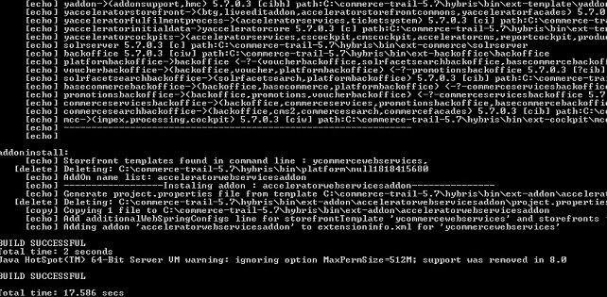
- To generate config, data, log, roles and temp folders
- Navigate to ext-template folder under bin folder
We need 7 extensions, but only two extensions are generated. So, in order to generate all the 7 extension, we need to modify few templates.
The templates are listed below:
- yacceleratorinitialdata
- yacceleratorstorefront
- yacceleratorcore
- yacceleratorfacades
- yacceleratortest
In every listed template folder look for extensioninfo.xml
Inside this file look for this particular entry

<meta key="modulegen-name" value="accelerator"/>
Add b2baccelerator in value attribute separated with a comma in extensioninfo.xml for every template listed above.
It should look like this:
<meta key="modulegen-name" value="accelerator,b2baccelerator"/>
NOTE: Please delete the custom folder

- Navigate to platform folder, and type the following command in CMD.
- setantenv.bat
- ant modulegen
>> Choose template as: b2baccelerator
>> Give module name as: eeyewear
>> Give package name as: com.eeyewear
NOTE: Please Comment or Delete yb2bacceleratorstorefront extension in localextensions.xml before ant modulegen
And we delete yb2bacceleratorstorefront extension in localextensions.xml as we will have eeyewearstorefront

It will generate 7 new custom extensions:

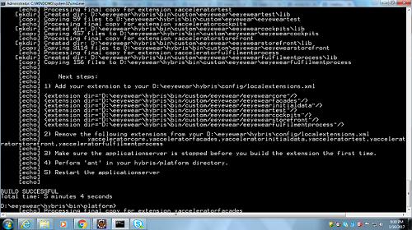

- Add all the extension generated to localextensions.xml
- Change the siteChannel.B2C to siteChannel.B2B in spring-filter-config.xml as shown below:
<alias name="b2cAcceleratorSiteChannels" alias="acceleratorSiteChannels"/>
<util:set id="b2cAcceleratorSiteChannels" value-type="de.hybris.platform.commerceservices.enums.SiteChannel">
<ref bean="SiteChannel.B2B"/>
</util:set>

( Location: hybris\bin\custom\eeyewear\eeyewearstorefront\web\webroot\WEB-INF\config\spring-filter-config.xml)
- Do ant clean all
- ant initialize
NOTE: Please remove website.powertools.http AND website.powertools.https from local.properties before pasting these 6 lines. A copy of these 2 lines are created as a part of the install.bat step
- Add these six lines in local.properties file

- eeyewearstorefront.webroot=/eeyewearstorefront
- storefrontContextRoot=/eeyewearstorefront
- website.powertools.http=http://powertools.local:9001/eeyewearstorefront
- website.powertools.https=https://powertools.local:9002/eeyewearstorefront
- website.eeyewear.http=http://eeyewear.local:9001/eeyewearstorefront
- website.eeyewear.https=https://eeyewear.local:9002/eeyewearstorefront
Also add powertools.local and eeyewear.local in hosts file
(Location: C:\Windows\System32\drivers\etc\hosts)

- hybrisserver.bat
- View the website by typing
http://powertools.local:9001/eeyewearstorefront
in the URL bar of the browser.

Deployment of eEyewear

Deployment of customizing eEyewear Store:
For deployment of custom eEyewear Store, go through below Document.

Working On a Team Forge project

- How to check-out source code into Team Forge repository:
- Go to the Source Code Tab of the repository from where you wish to take the code
- Take eEyewear Project URL (https://coconet-svn-in-01.capgemini.com/svn/repos/dcxeyewear) from Team Forge repository and check-out into your local repository.

- You can select the eEyewear repository name and browse your directory that contains all the required code as shown in the below figure
- When you click on the trunk folder you will be able to view the projects that contain two sub folders named config and extensions that are required to build your store.
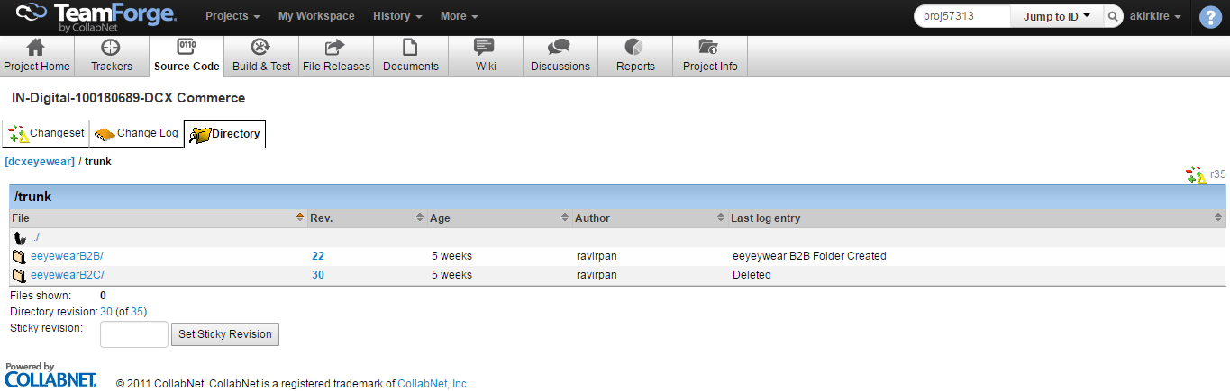
- Go to your eEyewear Folder and see the extensions folder will have all the extensions required as follows
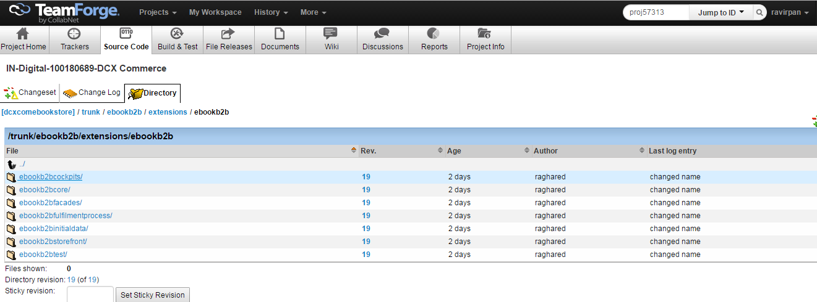

- How to check-in source code into Team Forge repository:
There are several ways to check-in the source code into your repository.
- Using repo browser:
- Right click on trunk folder and select TortoiseSVNRepo-Browser
- Adding the projects as defined in figure3, we need to check-in into your repository.
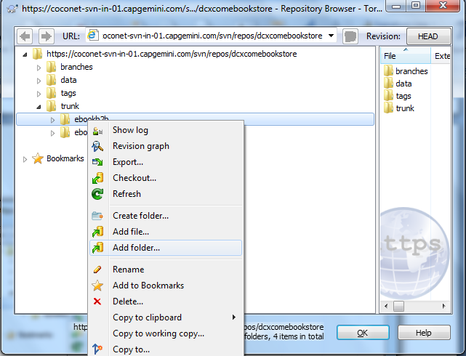

- Another way is to adding projects into repository:
Directly go to hybris directory and select which project need to import by using, Right click on folderTortoiseSVN->import
For example: adding config folder

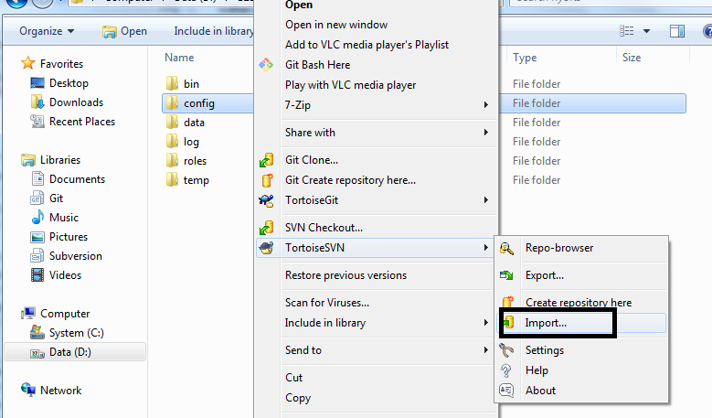
- Give full URL of repository and give import message and then ok.
https://coconet-svn-in-01.capgemini.com/svn/repos/dcxeyewear/trunk/eeyewear/config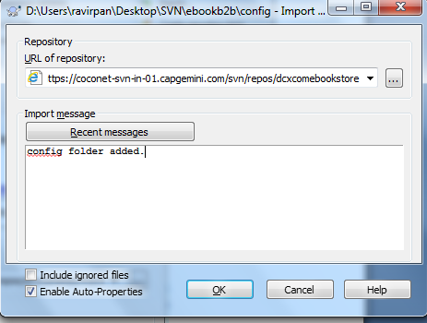

Working With SVN in Eclipse

Note: Before Working with SVN in Eclipse, We need install SVN Plug-in into your Eclipse.
For SVN plug-in, go to http://www.eclipse.org/subversive/

Steps for installation SVN plug-in:
Step 1

Start the installation process by going to Help->Install New Software

Step 2

An Install dialogue will appear, click on "Add".

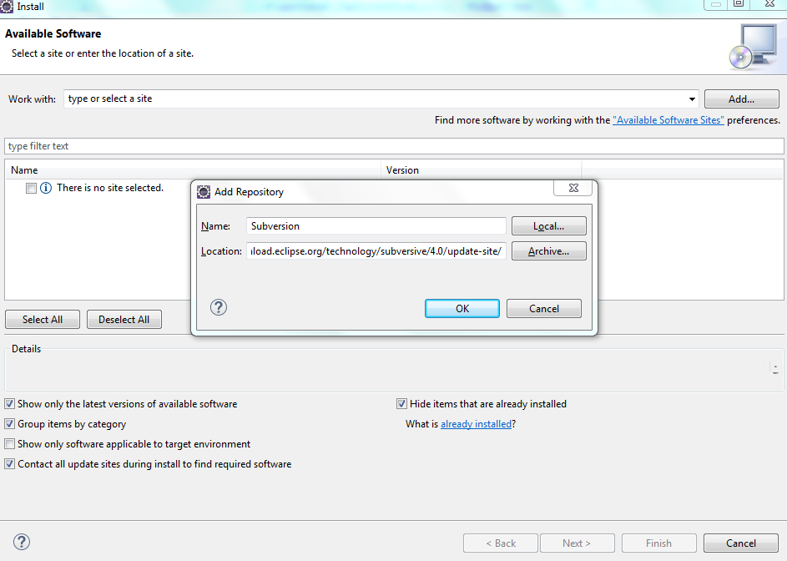

Step 3
Select all three bundles of software (Core SVNKit Library, Optional JNA Library, and Subclipse) and then click next.
Step 4
Click "next" again on the Install Details dialogue.
Step 5
Accept the license agreement and click finish. If while installing it warns you about installing unsigned content just click OK.
Step 6
Restart Eclipse and Subclipse will be installed.

Steps for Checkout code through Eclipse:

Window>Open Perspective>Other> SVN Repository
click Add SVN Repository > select URL > give Url : (https://coconet-svn-in-01.capgemini.com/svn/repos/dcxeyewear ) > Give your teamforge password > Finish

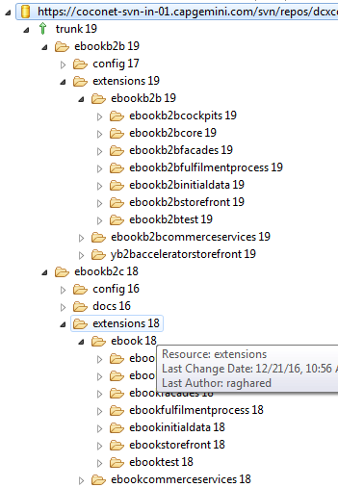

Committing Changes to the Repository:
A commit will enter your changes into the repository. Changes will only be entered into the repository when you commit, this includes adding and deleting files.
- right click on config folder go to Team> Commit
- Give commit message and click OK.

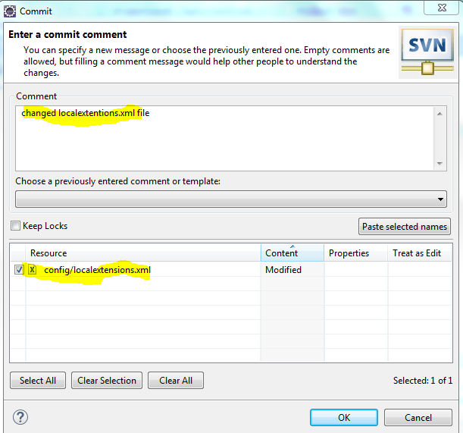
- Check your changes in your repository.

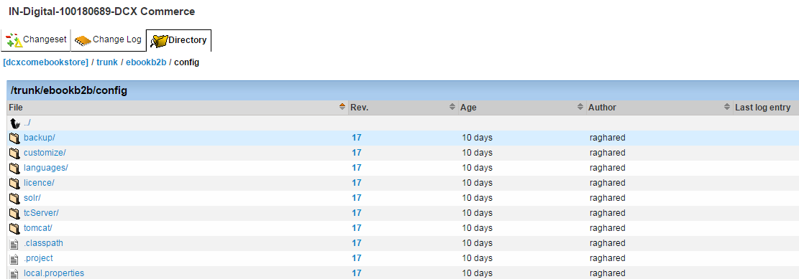

- You can see the difference whichever you commit in localexensions.xml file as below
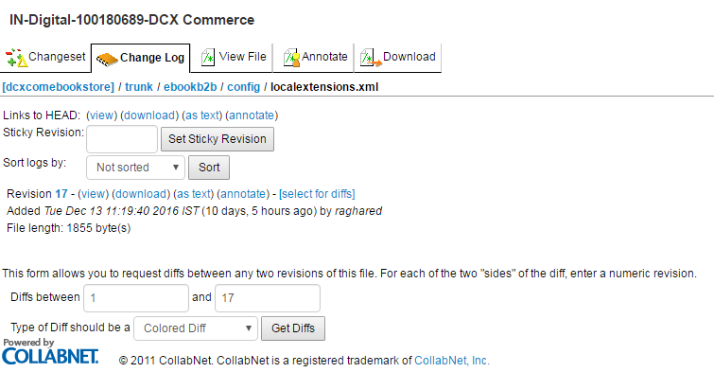
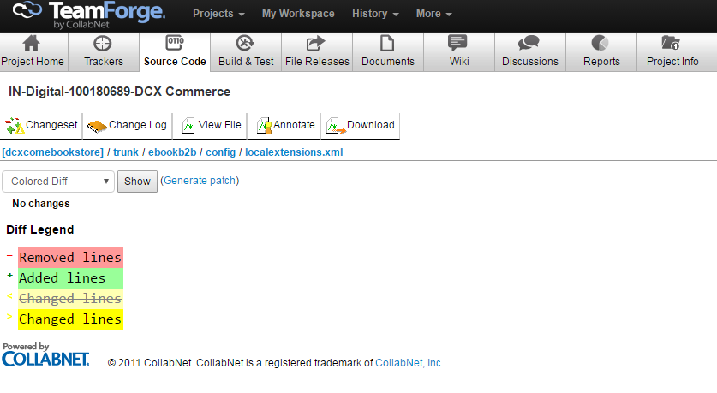

Documentation:

Go to team forge repository, select Documents Tab>see the documentation of eEyewear project as below diagram

